For this reason I kneel before the Father, from whom his whole family in heaven and on earth derives its name. Ephesians 3:14-15
Call to Worship Welcome, Pastor Brian
Announcements, and Opening Prayer Worship Leader: Terry Morr
Worship in Song
Brethren We Have Met To Worship
Worship Through Giving
Dedication of Our Gifts & Blessing

Worship in Prayer
Sharing Joys and Concerns
Family of God
Morning Prayer

Worship and The Word
The Church is God’s Family
Ephesians 3
Pastor Brian Layman

Worship to the World
Sending Song: In The Garden
During the closing song, you are invited to respond to God’s invitation by coming to the altar to receive the gift of salvation
through Jesus Christ, to rededicate your life and renew your faith, to express your desire for baptism or church membership, to
have prayer, or to receive anointing for any need. Deacons will be ready to pray with you.
Today’s Prayer Requests
Tina Hunt Ann Wilson (Tina’s Mom)
Nelson Hunt Bertha Hunt (Nelson’s Mom)
Carl & Doris (new living situation and healing)
Bonnie Kirkpatrick (surgery)
Phyllis Gould (Diane’s Mom) broken ankle
Don & Bonnie Cheek (Mary’s friends) Covid 19
Ruth Beck Doug Dawson
Guy Kirkpatrick (hip replacement on 5/11)
Scott Cawood (Minnesota Fires
Tina’s friend Louise Waller (fell)

Prayer Requests
In an effort to keep our prayer list relevant and updated, if you have a name/situation on the prayer list that has been resolved or needs to be removed would you do 2 things: share that joy during worship and let us know in the office so we can take care of that.
Thank you!

IN HONOR OF MOTHER’S DAY
Barbara Weiser of Kewanee, Illinois recalls this conversation with her daughter when she was six:
"Mom, there are five things I want to be when I grow up."
"Oh, yeah? What are they?"
"I’m going to be a model, a movie star, a traveler and travel all around the world, and an artist and a singer."
"What about a mom?"
"I don’t know... I think that’s too hard for me."
Later that same day, Abbie remarked to me, "Mom, it’s too bad you didn’t get to become anybody when you grew up."
"But I am somebody," I explained. "I’m your mom! If I weren’t a mom then you wouldn’t be here right now dreaming of what you want to be someday!"
My young daughter was perceptive about one vital thing.

Motherhood is not easy.
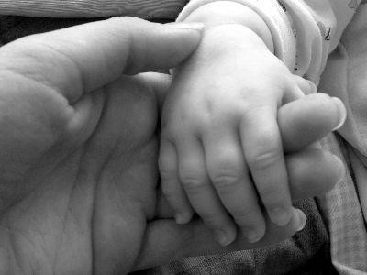
Ashland First Church of the Brethren
122 E. 3rd Street, Ashland, OH 44805
Sunday May 9, 2021
Mother’ Day
Worship 10:30AM
Pastor Brian Layman 330-887-2283
Deacon Chair Pete Snyder 419-289-3001
Church Board Chair Doug Dawson 567-215-6762

